MATCHPOINT TENNIS
1717 RT. 17M
Goshen, NY 10924
goshensportscomplex@yahoo.com
Phone 845-294-0017 or 845-615-8560
www.matchpointsports.com

WINTER 2020…GIRLS JV/VARSITY PRACTICE

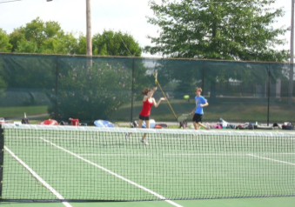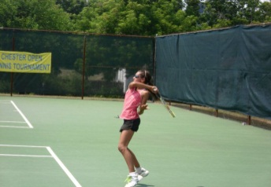

The MatchPoint Girls JV/Varsity Clinics are geared towards those players that would like to improve their JV/Varsity skill and make strides to improve their spot on their team. This clinic will be both drills and point play to fine tune the skills necessary to compete at the JV/Varsity Level.

SATURDAY 9:30AM-11:00AM…REGISTRATION NOW OPEN

1/04/20 – 1/11/20 – 1/18/20 – 1/25/20 – 2/01/20 – 2/08/20 – 2/15/20 – 2/22/20

NAME_______________________________________________________________________________

ADDRESS____________________________________________________________________________
PHONE_____________________________________________ E-MAIL__________________________

COST: $255.00 MEMBER $305.00 NON-MEMBER Middletown H.S. Discount
Available

CHECKS PAYABLE TO …………MATCHPOINT TENNIS

CHECK#__________ CREDIT CARD____________________________ EXP.________ CASH_________

If a class is missed, it can only be made up within the current 8 week clinic………..NO EXCEPTIONS

