MATCHPOINT TENNIS
1717 RT. 17M
Goshen, NY 10924
goshensportscomplex@yahoo.com
www.matchpointsports.com
Phone 845-294-0017 or 845-615-8560

WINTER 2023…LEARN TO PLAY ORANGE PRACTICE

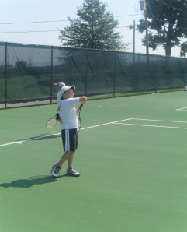
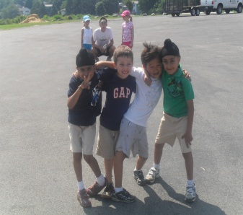
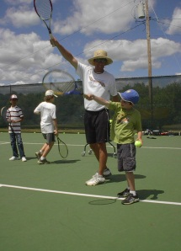
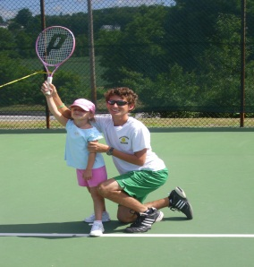
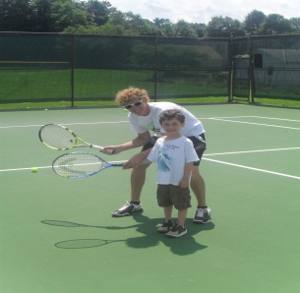

`

The MatchPoint Learn to Play Clinics are geared towards the player with limited playing experience.
This will be done with drills and games in a fun learning based environment.

MONDAY 5:00PM - 6:15PM
1/2/23 – 1/9/23 – 1/16/23 – 1/23/23 – 1/30/23 – 206/23 – 2/13/23 – 2/20/23
or
SATURDAY 12:30PM- 1:45PM
1/14/23 – 1/21/23 –1/28/23 – 2/4/23 – 2/11/23 – 2/18/23 – 2/25/23 – 3/04/23

***************************************************************************************

NAME________________________________________________________________________________________

ADDRESS_____________________________________City______________________State____Zip___________

PHONE_______________________________________________________________________________________

EMAIL_______________________________________________________________________________________

MONDAY_______________________________SATURDAY________________________________________

COST $256.00 MEMBER $296.00 NON MEMBER
Checks payable to Matchpoint

Check#________ Credit __________________________________________ EXP _________ CASH ______

Make ups are available on the other clinic day if unable to make scheduled day, must give 24 hour notice for make up

Classes may not be made up as Private Lessons…Non Transferrable to Private Lessons

