1717 Route 17M
Goshen, NY 10924
845-294-0017 or 845-615-8560
goshensportscomplex@yahoo.com

ADULT TENNIS
FRIDAY NIGHT MIXER 2020
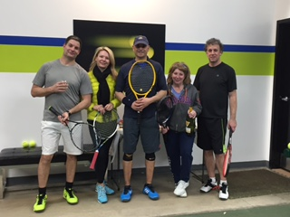

February 21st & March 13th, 2020
7:30 – 9:00PM

Have Fun and Mix it up with our Adult Round Robin Mixer. A MatchPoint Pro will facilitate fun doubles in a round robin format. Beverages and a lite snack will be served.
Name: ___________________________________________________________

Address: __________________________________________________________
Phone: ___________________________________________________________
E-mail: ___________________________________________________________

$20.00 Each Date Members $30.00 Each Date Non Members

Check # _____ Credit Card __________________ Exp. ________ Cash ________

