MATCHPOINT TENNIS
1717 RT. 17M
Goshen, NY 10924
goshensportscomplex@yahoo.com
www.matchpointsports.com
Phone 845-294-0017 or 845-615-8560

WINTER 2018/19…LEARN TO PLAY ORANGE PRACTICE

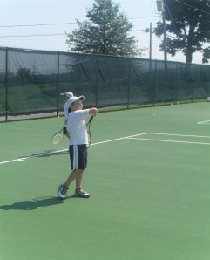
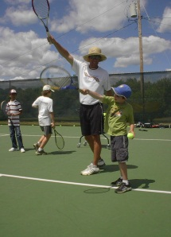
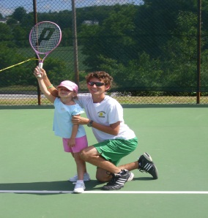
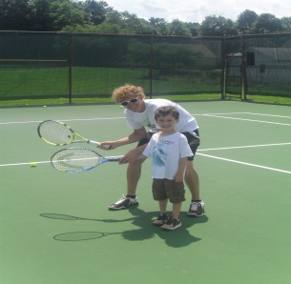

`

The MatchPoint Learn to Play Clinics are geared towards the player with limited playing experience.
This will be done with drills and games in a fun learning based environment.

MONDAY 5:00PM-6:15PM
11/5/18 – 11/12/18 – 11/19/18 – 11/26/18 – 12/03/18 – 12/10/18 – 12/17/18 – 1/7/19
OR
SATURDAY 12:30 PM-1:45 PM
11/3/18 – 11/10/18 – 11/17/18 – 11/24/18 – 12/01/18 – 12/8/18 – 12/15/18 – 12/22/18

***************************************************************************************

NAME________________________________________________________________________________________

ADDRESS_____________________________________________________________________________________

PHONE_______________________________________________________________________________________

EMAIL_______________________________________________________________________________________

MONDAY_______________________________SATURDAY________________________________________

COST $200.00 MEMBER $245.00 NON MEMBER
Checks payable to Matchpoint

Check#________ Credit __________________________________________ EXP _________ CASH ______

If a class is missed, it can only be made up within the current 8 week clinic………..NO EXCEPTIONS

