1717 Route 17M
Goshen, NY 10924
845-294-0017 or 845-615-8560
goshensportscomplex@yahoo.com
ADULT BEGINNER/3.0 DOUBLES CLASS

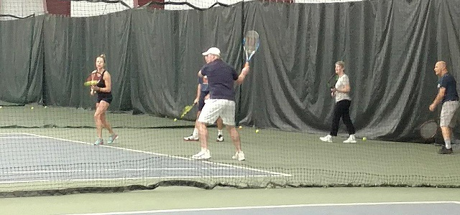

February 7th and March 26th, 2020
7:30PM – 9:00PM
MatchPoint tennis Coach will go over the ABC’s of poaching and shifting, and staggering.
Net play – being aggressive. Where to hit and when to close.
Serving and returning – strategies to start the point out strong.
Review and match play – utilize what we have learned

Name: ___________________________________________________________

Address: __________________________________________________________
Phone: ___________________________________________________________
E-mail: ___________________________________________________________

$20.00 Each Date Members $30.00 Each Date Non Members

Check # _____ Credit Card __________________ Exp. ________ Cash ________

