MATCHPOINT TENNIS
1717 17M
Goshen, NY 10924
goshensportscomplex@yahoo.com
www.matchpointsports.com
Phone 845-294-0017 or 845-615-8560
WINTER 2023…PIP SQUEAK TENNIS PRACTICE

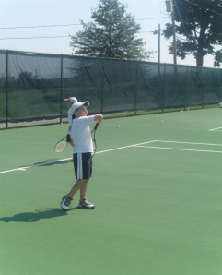
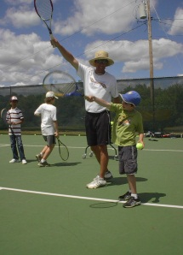
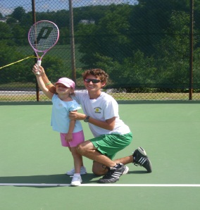
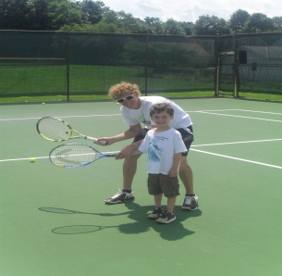

`

The MatchPoint Pip Squeak Practice is open to 3 to 6 year olds and geared towards the player with limited playing experience. This will be done with drills and games in a fun learning based environment.

SATURDAY 12:30 PM-1:15 PM

1/14/23 – 1/21/23 – 1/28/23 – 2/4/23 – 2/11/23 – 2/18/23 – 2/25/23 – 3/04/23

***************************************************************************************

NAME________________________________________________________________________________________

ADDRESS_________________________________________CITY__________________________STATE_________

PHONE_______________________________________________________________________________________

EMAIL_______________________________________________________________________________________

SATURDAY________________________________________

COST $256.00 MEMBER $281.00 NON MEMBER
Checks payable to Matchpoint

Check#________ Credit __________________________________________ EXP _________ CASH ______
If a class is missed, it can only be made up within the current 8 week clinic………..NO EXCEPTIONS. Must call 24 hours in advance for makeup.
Classes may not be made up as lesson…Non transferrable to Private Lessons

