MATCHPOINT TENNIS
1717 RT. 17M
Goshen, NY 10924
goshensportscomplex@yahoo.com
Phone 845-294-0017 OR 845-615-8560
www.matchpointsports.com

FUTURES GREEN WINTER 2023 PRACTICE
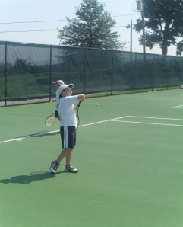
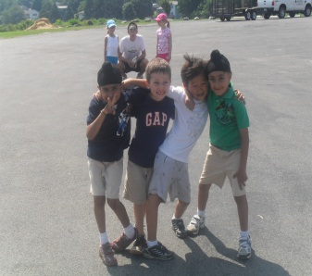
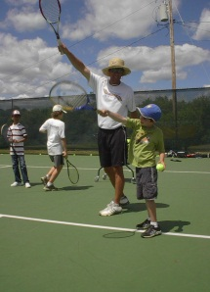
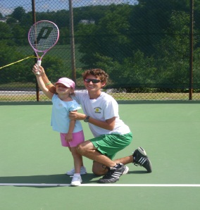
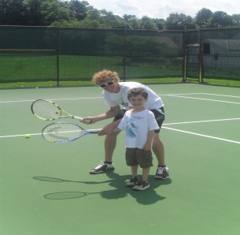

Open to all graduates of Learn to Play read the new players 10 to 12 years old. Able to move to futures when a player demonstrates the proper technique with all ground strokes serves and volleys. Can demonstrate simple consistency (3 in a row) on the full-sized court. Able to keep Score.

WEDNESDAY 4:30PM - 6:00PM
12/28/22 – 1/04/23 – 1/11/23 – 1/18/23 – 1/25/23 - 2/01/23 – 2/08/23 – 2/15/23
or
FRIDAY 4:30 – 6:00PM
12/30/22 – 1/06/23 – 1/13/23 – 1/20/23 – 1/27/23 – 2/03/23 – 2/10/23 – 2/17/23
or
SATURDAY 11:00AM- 12:30PM
1/14/23 – 1/21/23 – 1/28/23 – 2/04/23 – 2/11/23 – 2/18/23 – 2/25/23 – 3/04/23

NAME___________________________________________________________________________________________

ADDRESS__________________________________ CITY__________________ STATE______ ZIP_____________

PHONE___________________________________________________________________________________________

EMAIL___________________________________________________________________________________________

WEDNESDAY_____________________ FRIDAY __________________ SATURDAY____________________

COST : $336.00 MEMBER $376.00 NON MEMBER

2 CLASSES PER WEEK: $616.00 MEMBER $656.00 NON MEMBER

CHECKS PAYABLE TO………………… MATCHPOINT TENNIS

CHECK#__________ CREDIT CARD _____________________________ EXP. ________CASH_____________

If a class is missed, it can only be made up within the current 8 week session on another clinic day………..NO EXCEPTIONS. Must call 24 hours in advance for makeup.
Classes may not be made up as Private Lessons…Non transferrable to Private Lessons

