MATCHPOINT TENNIS
1717 RT. 17M
Goshen, NY 10924
goshensportscomplex@yahoo.com
Phone 845-294-0017 OR 845-615-8560
www.matchpointsports.com

FUTURES GREEN WINTER PRACTICE 2020

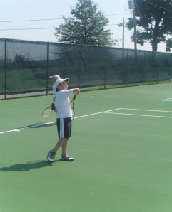
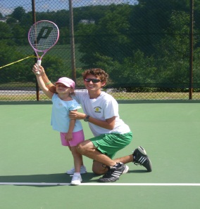
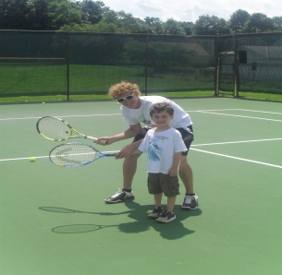

The MatchPoint Futures Practice is open to all graduates of Learn to Play and players with limited
playing experience. This will be done with drills and games in a fun learning based environment.

WEDNESDAY 4:30PM - 6:00PM
1/08/20 – 1/15/20 – 1/22/20 – 1/29/20 – 2/05/20 – 2/12/20 – 2/19/20 – 2/26/20
or
SATURDAY 11:00AM- 12:30PM
1/04/20 – 1/11/20 – 1/18/20 – 1/25/20 – 2/01/20 – 2/08/20 – 2/15/20 – 2/22/20

NAME___________________________________________________________________________________________

ADDRESS________________________________________________________________________________________

PHONE___________________________________________________________________________________________

EMAIL___________________________________________________________________________________________

WEDNESDAY_______________________________SATURDAY___________________________________

COST : $255.00 MEMBER $305.00 NON MEMBER

2 CLASSES PER WEEK: $465.00 MEMBER $525.00 NON MEMBER

CHECKS PAYABLE TO………………… MATCHPOINT TENNIS

CHECK#__________ CREDIT CARD _____________________________ EXP. ________CASH_____________

If a class is missed, it can only be made up within the current 8 week clinic………..NO EXCEPTIONS.

