MATCHPOINT TENNIS
1717 RT. 17M
Goshen, NY 10924
Phone 845-294-0017
goshensportscomplex@yahoo.com
www.matchpointsports.com
WINTER…2023 ELITE PRO 1 PRACTICE
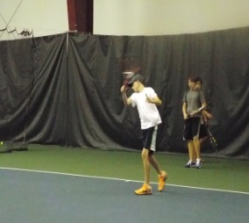
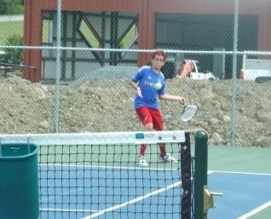
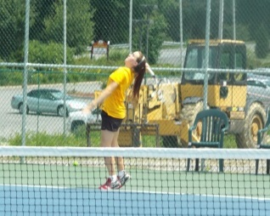

The MatchPoint Elite Pro 1 Practice is geared towards preparing top level Girls/Boys who are looking to become top varsity players and establish themselves in USTA events. The programmed is designed to teach the skills and strategy necessary to compete at the highest level in varsity and USTA tournaments. Players must be playing or trying out for varsity tennis.

Approval Required. Must attend minimum of two classes per week. Can attend no more than 16 classes per session.
TUESDAY 5:00PM - 6:30PM
12/27/22 – 1/03/23 – 1/10/23 – 1/17/23 – 1/24/23 – 1/31/23 – 2/07/23 – 2/14/23

THURSDAY 3:30PM – 5:00PM
1/05/23 – 1/12/23 – 1/19/23 – 1/26/23 – 2/02/23 – 2/09/23 – 2/16/23 – 2/23/23

SUNDAY 10:30AM – 12:00PM
1/15/23 – 1/22/23 – 1/29/23 – 2/05/23 – 2/12/22 – 2/19/23 – 2/26/23 – 3/05/23

NAME______________________________________________________________________________

ADDRESS___________________________CITY_________________STATE_____ZIP___________

PHONE_____________________________________________________________________________
_
EMAIL_____________________________________________________________________________

TUESDAY ________________THURSDAY______________ SUNDAY _____________________
COST 2 CLASSES PER WEEK $599.00 MEMBER $649.00 NON MEMBER
CHECKS PAYABLE TO: ………MATCHPOINT TENNIS

CHECK#__________ CREDIT CARD ____________________________ EXP. _________CASH________

NO PAY AS YOU GO
If a class is missed, it can only be made up within the current session………..NO EXCEPTIONS

